
Cacapon Institute
#10 Rockford Road
Great Cacapon, West Virginia 25422

Cell: 540 335-0687 Office: 304-258-8013

ctree@cacaponinstitute.org

http://www.cacaponinstitute.org

COMMUNITREE APPLICATION

“
“Building Communities from the Roots Up”
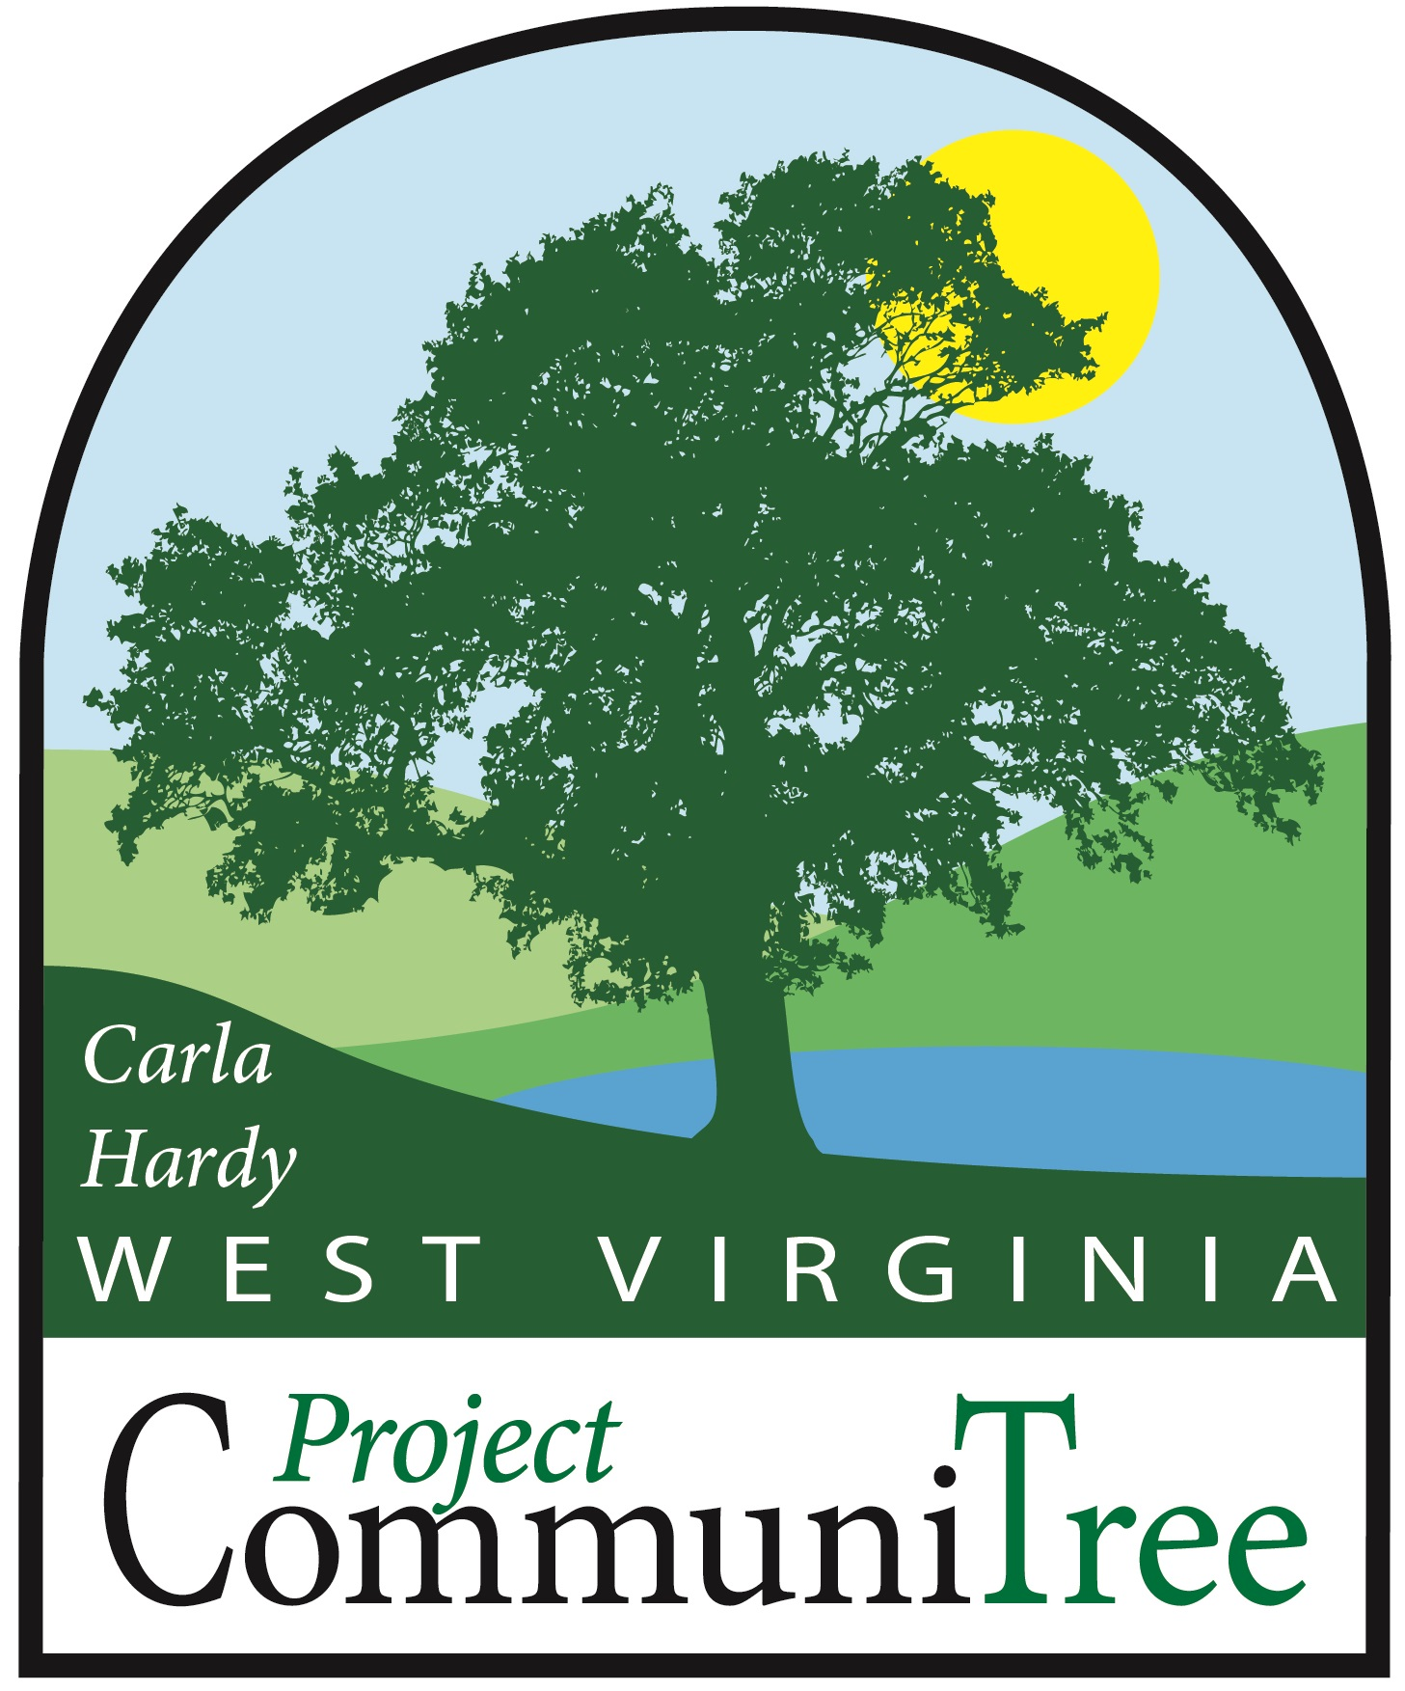



 | Spring | Fall
Pre-Proposal Due | Feburary 1st | July 1st
Award Notification | Febuary 15th | July 15th
Welcome Packets Due | February 15th | August 15th
Planting Season | April 1st – May 15th | October 1st – November 15th
Project Leader Reporting Due | May 16 | December 1st
CTree Care & Maintenance | Ongoing | Ongoing

Cacapon Institute does not discriminate on the basis of race, color, national origin, or sex.
We strive to be inclusive, regardless of age or disability, and seek a diverse workforce and audience.

What is “Carla hardy wv project communitree”?
Carla Hardy WV Project CommuniTree (CTree) is a program of Cacapon Institute that is supported by the WV Chesapeake Bay Program, including the WV Department of Agriculture, WV Division of Forestry, WV Conservation Agency, and the Eastern Panhandle Regional Development & Planning Council. Technical and financial support is provided by these partners and additional federal, state, and local organizations.

The ultimate goal of CTree is to protect rivers and watersheds by reducing stormwater runoff pollution to help restore local streams, rivers, and ultimately the Chesapeake Bay. To

achieve this goal, CTree promotes planting urban trees on publicly-used lands in the Potomac Highlands.
- “Urban trees” are the trees we live with, the trees that grace our towns, neighborhoods, parks, schools, and roadsides. Urban trees protect West Virginia’s rivers by reducing stormwater runoff pollution. They provide many additional environmental, social, and economic benefits to communities.
- “Publicly-used lands” include public properties (schools, parks, road right-of-ways, etc.) as well as privately-owned properties that serve a public or community function (HOA common areas, churches, cemeteries, etc.)
- “Potomac Highlands” are the eight counties of the eastern panhandle of WV (Jefferson, Berkeley, Morgan, Mineral, Hampshire, Hardy, Grant, and Pendleton counties).

Additional goals for CTree include:
- Increasing urban tree canopy in the Potomac Highlands
- Fostering an increased awareness of local water quality issues
- Educating volunteers on the benefits of trees and proper tree selection and care
- Promoting long-term tree care programs within participating communities
- Connecting volunteers with resources to make positive changes in their communities

The CTree slogan is “Building Communities from the Roots Up!” , so we prioritize projects that engage whole communities and strive for diversity and inclusiveness.

Cacapon Institute and our partners invite groups in the Potomac Highlands of West Virginia to apply for free “CTree Kits” to plant trees on publicly-used land. Applicants are responsible for:
- Submitting this application by the deadline:
  - February 1st for spring plantings (April 1st – May 15th)
  - July 1st for fall plantings (October 1st – November 30th)
- If awarded, planning & implementing a successful community tree planting. This includes organizing all aspects of the planting, fostering at least $1,500 in volunteer contribution (see page 13), and submitting the final Planting Report.
- Maintaining their trees (see Maintenance Agreement on page 11)

Application requirements, deadlines, and information on how to apply are listed below. After reading the application groups are encouraged to contact Cacapon Institute’s Communitree Coordinator, Jeff Iliff directly with any questions or concerns by emailing ctree@cacaponinstitute.org or by calling 540-335-0687. Cacapon Institute staff can meet with you on site to discuss your needs and help you better understand the program and application.

How do we apply for CTree?
Cacapon Institute welcomes applications from any community-based organization, including:
- Service, youth, civic, and social organizations
- Faith-based organizations of all denominations
- Tree boards, watershed groups, and other environmental service organizations
- Public and independent K-12 schools, as well as other educational institutions
- Municipal, county, regional, and state institutions

Application Requirements:
- Project must take place on publicly-used property in the Potomac Highlands
- Demonstrate strong volunteer and education objectives in their proposal
- Explain the ecological, social, and environmental benefits of their tree planting
- Fulfill the $1,500 volunteer contribution through volunteerism or material donations

Application Components:
- Cover Sheet – Page 6 (5 Points)
- Proposal – Pages 7-9 (70 Points)
- Site Checklist – Page 10 (5 Points)
- Signed Tree Maintenance Form – Page 11 (5 Points)
- Liability Waiver – Page 12 (5 Points)
- Estimated Volunteer Contribution – Page 13 (5 Points)
- Site Photos and Proposed Planting Plan (Submit with application – 5 Bonus Points)
- Past Performance with CTree Projects (5 Points – Automatic 5 points for all new groups applying for a CTree kit for the first time)

Ready to apply?
Once your application is complete, please send your application:
- By email (preferred), to Cacapon Institute at ctree@cacaponinstitute.org
- By postal service, to Cacapon Institute c/o WV Project CommuniTree at:
  - 10 Rockford Road, Great Cacapon, WV 25422

how can we write a successful application?
- The most successful applications come from groups that consult with us during the application process. We can provide a site visit to help you determine the best tree planting site and the best CTree Kit for that particular site, as well as answer any questions you have about the program and your responsibilities.
- Read all directions! Make sure your application includes all necessary components. Pay very close attention to the points system as it will give an indication of which application components we value the most.
- Be creative! Think outside the box and have fun! Preference will be given to applications that encourage community pride and are inclusive of the entire community.
- Be specific! The narrative should be easy to read, clearly written, and should present your ideas in an exciting yet specific manner. Preference will be given to groups that clearly demonstrate their community’s needs and how the goals of your project align with the goals of the CTree program.
- Find Partners! Projects are more successful when they have multiple partners with varying skills, experience, and knowledge that add to the overall success of the planting.
- Follow through! Cacapon Institute can only support applications that demonstrate your group’s commitment to fulfill the volunteer contribution and tree maintenance requirements. (Groups that do not meet their stated commitments will not be allowed to reapply until they fulfill all requirements from their first planting)

Groups applying for CTree Kits for plantings on road right-of-ways along Route 9, Corridor-H, or county roads must follow all local ordinances, laws, and regulations for parking and use and access of road right-of-ways. Safety should always be your first priority.

WHat are “CTree Kits”?
Cacapon Institute has prepared a list of suggested “CTree Kits” so that successful applicants do not have to take responsibility for purchasing trees and materials. If awarded, Cacapon Institute will purchase your trees, as well as tubes, stakes, cages, etc. at a wholesale rate and deliver them in the form of a “CTree Kit” to one of the four following pickup locations:

Moorefield: WV Conservation Agency Moorefield Field Office, 60 C Industrial Park Road, Moorefield, WV 26508
Inwood: WV Division of Forestry, 145 Pilgrim Street, Inwood, WV 25428
Great Cacapon: 10 Rockford Road, Great Cacapon, West Virginia 25422
Wardensville: 28813 WV-55 Wardensville, West Virginia 26851
On your application Cover Sheet, please indicate by “CTree Kit” the mix of trees that best fits your site. You’ll need to assure us that this is the right CTree Kit for your site by filling out the Site Checklist on page 10.

In your proposal, specifically discuss your CTree Kit choice. Be aware that, depending on nursery availability, your kit may not be available exactly as listed in the table below and is subject to changes and variations in species and stock size.

Which “CTree Kit” Should we request?
Below is a list of the CTree Kits that you can request. The species listed are examples of what could be included in each kit, but are not a definitive listing of available species. CTree Kits can be modified to suit your planting site, but any specific requests must be marked by checking “Specific Trees” on Page 6 of your application and then detailing your requests on Page 8.
Kit |  | Stock Size |  | Example Projects | Example Species  (SUBJECT TO CHANGE)
Shade-16 | 16 7-gallon, 6’ (+/-) trees |  | Rock Spring Church |  | White oak, red maple, sugar maple, red oak, sycamore, tulip poplar, sweet gum, swamp white oak, river birch, hackberry, American linden
Shade-24 |  | 12 7-gallon, 6’ (+/-) trees  12 3-gallon, 4’ (+/-)trees |  | Mill Creek  Ruritan Club
Evergreen-24 |  | 12 7-gallon, 6’ (+/-) trees  12 3-gallon, 4’ (+/-) trees |  | Romney Middle School | White pine, eastern red cedar, Norway spruce, arborvitae, American holly, Virginia pine, pitch pine, loblolly pine
Evergreen-50 |  | 6 7-gallon, 6’ (+/-) trees  44 3-gallon, 4’ (+-/-) trees |  | North Jefferson Elementary School
Evergreen-100 |  | 100 3-gallon 4’ (+/-) trees |  | 522 Business Park
Bantam-24 |  | 12 7-gallon, 6’ (+/-) trees  12 3-gallon, 4’ (+/-) trees |  | Olivet Cemetery Association | Eastern redbud, serviceberry, flowering dogwood, sweet bay magnolia, hawthorn, Japanese cherry
Mixed-16 |  | 16 7-gallon, 6’ (+/-) trees |  | Martin Robinson Delany OLC School | Customizable mixes of shade, evergreen, and flowering trees. Consult with our CommuniTree Coordinator, Jeff Iliff, to determine a mix that best suits your planting site. He can be reached at ctree@cacaponinstitute.org or by phone at 540-335-0687.
Mixed-24 |  | 12 7-gallon, 6’ (+/-) trees  12 3-gallon, 4’ (+/-) trees |  | Berkeley County PSSD
Mixed-50 |  | 6 7-gallon, 6’ (+/-) trees  44 3-gallon, 4’ (+/-) trees |  | Windmill Crossings HOA
Riparian-50 |  | 6 7-gallon, 6’ (+/-) trees  44 3-gallon, 4’ (+/-) trees |  | Romney Business Park | Sycamore, swamp white oak, river birch, black cherry, pin oak, black willow, red maple, hackberry, sweet gum
Riparian-100 |  | 100 3-gallon, 4’ (+/-) trees |  | Wardensville Garden Market

Cover sheet (5 Points)
Group Information

Group Name:___________________________________________________________________
Group Type:____________________________________________________________________

Name of Project Leader: __________________________________________________________

Job Title: ______________________________________________________________________

Project Leader Mailing Address:____________________________________________________

Work Phone #_____________________________ Cell Phone # ________________________

Email: _________________________________________________________________________

Planting Site Information

Planting Site:___________________________________________________________________

Planting Site Type:_______________________________________________________________

Project Site Address:_____________________________________________________________

Property Owner: ___________________________ Permission for Planting (Check Box)______
(Permission must be obtained to be awarded a CTree Kit)

City:____________________________________ County: _______________________________

Project Information

Planting Season: ________________________________________________________________

CTree Kit:__________________________________ Specific Trees?_____________________

Preferred Pickup Location:

Tree Pick-up Date:______________________ Tree Planting Date: ______________________

Project Abstract (Briefly describe your project in less than 3 sentences. If you are requesting specific trees with your tree kit, please note those requests on Page 8):

If project is accepted, we grant CTree permission to contact us annually and use tree planting and site pictures for future CTree publications. (Check Box)

Proposal (70 Points)
Please answer the following questions thoroughly in your proposal on pages 7-9. This is the most important part of your application. Make sure your proposal is aligned with Cacapon Institute’s goals for the CTree program on page 2. Each of the four questions are broken down into smaller parts to make it easier for you to provide 3-4 sentences for each question.

1.) Organizational Info - 10 Points
Tell us more about your organization, what you do, who you serve, and why:

  - What is the mission, goal, and objective of your organization?

  - What programs and services does your organization currently provide?

  - Tell us about how your group is organized (Board, staff, population served, etc.)

  - Tell us about your previous experiences organizing community tree plantings or other community-based volunteer projects.

2.) Description of Need (25 Points)
See page 2 for CTree goals. Preference will be given to groups that demonstrate how their tree planting will reduce stormwater runoff pollution, increase tree canopy, and help “Build Communities from the Roots Up!” Use these goals to help describe in general terms what “problem” your group is addressing.

- What is the issue you plan to address?

- If you are requesting specific trees for your CTree Kit, please describe what species you are requesting in this section.

3.) Objectives and Goals of your Project (20 Points)

- What are the short-term and long-term objectives, goals, and benefits of your project? Explain how your project specifically addresses the issues described on the previous page.

- Additionally, discuss how your project will foster volunteerism in your community and your plans to educate volunteers about the benefits of, and proper care for, trees.

4.) Tree Maintenance & Volunteer Contribution (15 Points)

- Describe how your trees will be maintained (please reference the Maintenance Agreement on Page 11). It isn’t the number of trees we plant but the number of trees we grow that is the measure of success. Specifically, talk about who will be watering the trees, how often, using what equipment, etc. and how you will maintain your trees over time.

- How will you exceed the $1,500 volunteer contribution?
Priority will be given to applicants that can clearly demonstrate their ability to not just meet, but exceed, the $1,500 volunteer contribution requirement.

Site checklist (5 POINTS)
In 100 words or less, describe your proposed tree planting site. Where are you planting the trees and what does the site currently look like?

What percentage of the site is: Tree Canopy? _____ Mowed Turf? _____ Exposed Soil?_____

Planting Conditions (check all that apply)

Sunlight Exposure – Full sun__________ Part Sun_____________ Shade________________

Topography – Steep slopes_________ Rocky conditions _________ Ditches _____________

Soil Condition – Good (loose/fluffy)_______ Bad (rocks/clay) ________ Not sure _________

Site Hydrology – Dry (upland) _________ Wet (riparian) ________ Not sure __________

Site Exposure – Windy ______________ Prone to temperature extremes _______________

Has there been recent construction or soil erosion that has exposed soil?__________________

Does the site receive excess salt from roads or any other soil contaminants? _______________

Potential Planting Conflicts (check all that apply)

Utilities – Overhead wires (phone/electric)__________ Underground utilities_____________
(It’s the law to call Miss Utility to determine location of underground utilities)

Structures & Infrastructure (Are any of these directly adjacent to the proposed planting site?)

Sidewalks________ Buildings ________ Roads _________ Other structures ________

Describe:

Other potential planting conflicts (Are there any other potential planting conflicts?)

Mowing Conflict_______ Heavy pedestrian traffic_______ Other potential conflict______

Describe:

Maintenance agreement (5 Points)
In consideration of Cacapon Institute providing trees and planting materials through the Carla Hardy WV Project CommuniTree (CTree), we agree to the following: (must check all boxes)

- Grant Cacapon Institute staff, volunteers, and contractors permission to inspect and/or provide maintenance recommendations for trees planted at:

________________________________________________________________________
Planting Site Address City State Zip

- Provide proper maintenance for trees planted through the program, including:
  - Year 1
    - Watering your trees with at least 5-10 gallons of water per tree each week, as needed, depending on soil conditions and precipitation.
    - Maintaining and monitoring tubes, stakes, arbor strap, and other protective devices and then removing them after 1 year.
  - Years 2-5
    - Periodically watering during droughts, especially in years 2-3
    - Annually reapplying a 3-inch deep layer of hardwood mulch, 3 feet in diameter, around each tree. Mulch should not be piled up against the tree trunk, but should instead maintain a 3-inch gap between the trunk and the start of the mulch ring.
  - Years 5+
    - Continue mulching annually and periodically watering during droughts
    - Not topping, heading, or rounding over any tree planted through the CTree program. We agree to maintain the tree’s natural canopy shape and size during all pruning events.

- Hold Cacapon Institute and its partners, volunteers, and contractors harmless from any liability arising from the planting or care of any trees planted under this agreement.

Failure to fulfill these maintenance requirements will make your group ineligible to apply for CTree Kits and technical assistance in the future.
____________________________________________ ___________________________
Name Date

______________________________________________________________________________
Mailing Address

______________________________________________________________________________
City State Zip

________________________________________ __________________________
Email Phone

Liability Waiver (5 Points)
As the Project Leader, I understand that the volunteers that work on this project freely choose to be involved in activities requiring physical activity, activities in or on waterways, travel, contact with foreign and unidentified substances and other potential risks of injury or death. I agree that the volunteers that work on this project and I will only perform activities which we are competent to perform and feel comfortable doing. The volunteers that work on this project and I assume any and all risks, whether known or unknown, associated with performing each activity.

The volunteers that work on this project and I hereby release Cacapon Institute, our partners and contractors, and all other sponsors and volunteers from any and all actions, causes of action, claims or any liabilities whatsoever, including negligence, for any harm that befalls them or me, or any equipment in my possession or control that arises out of the activities of any volunteer. We also agree to indemnify and hold harmless said parties for any damages or liabilities to third parties that arise out of our activities as volunteers. This waiver has no expiration date.

I hereby release the property owner(s) named below from any and all actions, causes of action, claims or any liabilities whatsoever, including negligence, for any harm that befalls any volunteers or me, or any equipment in our possession or control that arises out of the activities of volunteers or myself.

Property Owner Name:___________________________________________________________

Planting Site Address:____________________________________________________________

This waiver is given in the interest of permitting these volunteer programs to exist and to serve the community at large, and to enable volunteers for this project and me to feel free to participate as a volunteer member without fear of liability.

I understand that it is my responsibility as Project Leader to read and explain this Liability Waiver to all volunteers actively participating in this project and to ensure they fully understand the policy.

Project Leader Name:___________________________________________________________

Date:__________________________________________________________________________

Estimated Volunteer Contribution (5 points)

See examples online at http://www.cacaponinstitute.org/Forestry/CTree.htm. Your goal is to demonstrate an estimated contribution of at least $1,500 through volunteerism and donations.

Item | Description | Date(s) | Quantity | Hours | Rate/Unit | Total
Leadership, Planning, & Organizing (all volunteerism before planting day)
 |  |  |  |  | 22.29
Planting Day (all volunteerism during planting day)
Heavy Equipment (all heavy equipment for picking up trees, auguring the holes, etc.)
Material Donations & Purchases (all additional material donations or project-related purchases)
Total

Species and stock size are subject to change based on nursery availability

