Potomac Headwaters Leaders of Watersheds
Grow-a-Garden Application

Educating future generations of environmental stewards through classroom education and on the ground conservation practices at schools.

Grow-a-Garden
Grow-a-Garden focuses on stormwater runoff pollution, the harmful materials from hard surfaces such as rooftops and parking lots that rainwater carries to streams. Unmanaged stormwater runoff pollution carries oil, agricultural waste, and nutrients and sediment to streams which degrades drinking water quality and harms wildlife.
What is a Rain Garden?
Rain gardens are a shallow depression or low laying area that collects stormwater runoff, allowing it to be cleaned and infiltrate back into the ground.

Grow-a-Garden helps students discover the connections between land use practices and the health of rivers while simultaneously linking learning standards. Students discover that human impacts on land and water affect the organisms that live in streams through classroom exploration of four instructor-led classes.

Lesson Topics:
- Watersheds: What are they? Do I live in one?
- Nutrient and Sediment Pollution: How does this pollution harm rivers?
- Benthic Macroinvertebrates: What are they? What do they tell us about the health of our rivers?
- Rain Gardens and Native Plants: What are they and how do they reduce pollution?

Program Includes:
- Four fifty-minute classroom education sessions led by CI’s Watershed Education Specialist
- Assistance with selecting rain garden location on school property and garden design
- All plants and mulch (unless donated)
- Professional preparation of rain garden prior to planting

At the conclusion of the education sessions, students understand the role their rain garden will play in their local watershed and ultimately the Chesapeake Bay. The rain gardens not only capture stormwater runoff pollution, they provide an outdoor classroom for the school to use in science, art, and math lessons.

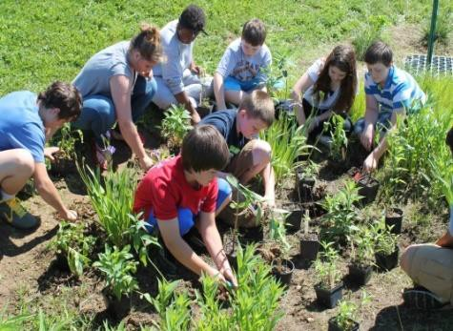

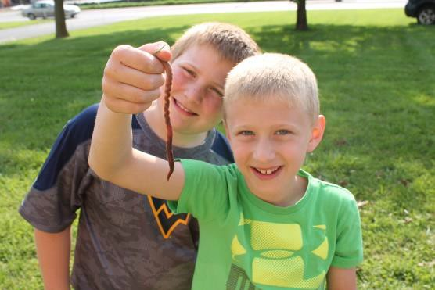

Requests welcome from:
- Public or private schools within the Potomac River Watershed, including those located in the Eastern Panhandle of West Virginia, the Shenandoah Valley of Virginia, or Western Maryland

Application Requirements:
- Program takes place within a school system and on school property
- School located within the Potomac River Watershed
- Commitment to coordination of class lessons instructed by Cacapon Institute
- Assistance in the planning and execution of the conservation practice installation
- Keep an ongoing record of volunteer contribution for submission of final project report at the conclusion of the project
- Ongoing maintenance of rain garden

To Apply:
- Email Application: Watershed Education Specialist, Cacapon Institute
phlow@cacapo nInstitute.org

Note: Please apply for only one program a season. We encourage whole grade levels to participate.

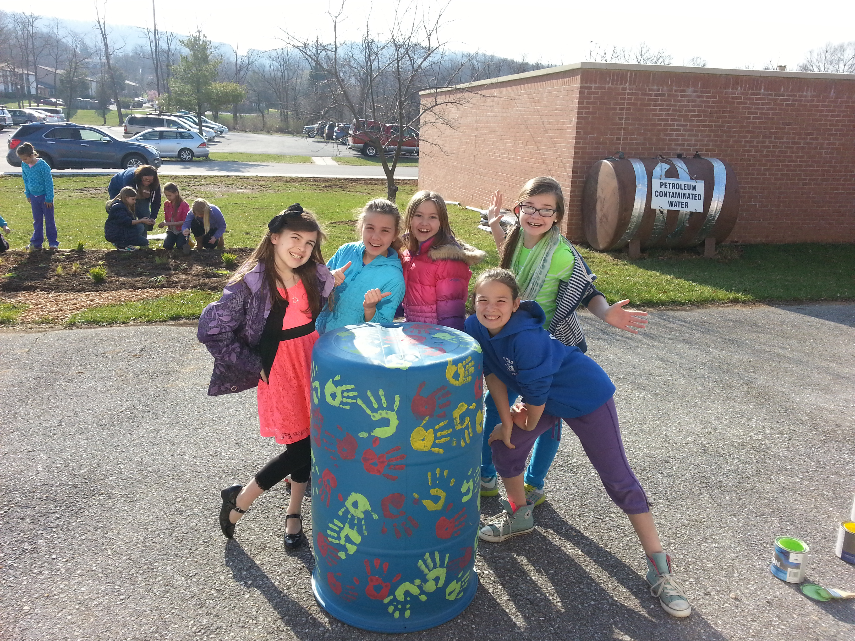

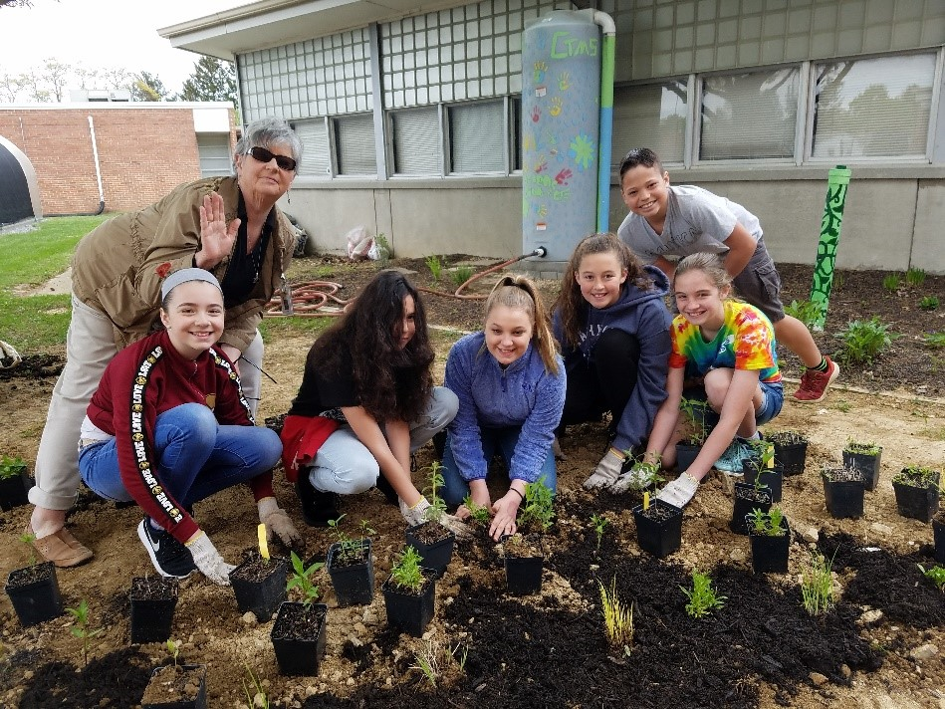

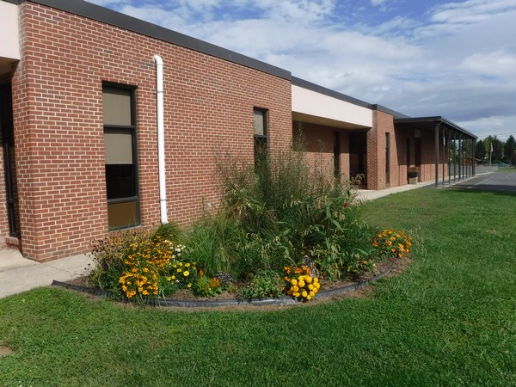

G row-a-G ard e n PH LOW Prop os al

Cover Sheet

School Name:

School Address: |  |  | County, State:
Grade(s) Level: | Number of Classes: |  | Total Number of Students:
Name of Project Leader: |  |  | Job Title:
Phone Number: |  | Email:

Suggested Education Dates: These will allow the watershed education specialist an opportunity to create a schedule for spring projects. Please provide a different education date for each of the four lessons (we recommend a lesson a week). Provide a planting and rain date between for the project.

Lesson: | What are Watersheds? | Pollution Problems | Stream Creatures | What is a Rain Garden? | Planting Day | Rain Date
Tentative Dates:
Class Schedule: Provide an agenda for the watershed education specialist to follow on education days.

Teacher Name | Class Time | Grade Level | # Students

Project Abstract (briefly describe your project in less than five sentences):

If project is accepted, we grant Cacapon Institute permission to contact us annually and use planting and site pictures for future publications. (Check Box)

- Description of Need. Please be sure to address the following:
  - What do teachers hope their students will gain from the four educational sessions?
  - How will a rain garden be an asset to the school in regards to reducing stormwater runoff pollution, flooding or mud issues, and future educational uses?
  - Has your school installed a conservation project before?

Objectives and Goals for this Request
What are the short-term and long-term objectives, goals, and benefits of this program? How will the program foster community involvement and outdoor learning opportunities?

Site Checklist
Soil Texture:
- Sand
- Clay
- Loam
- Combination:
Soil Compaction:
- Severe
- Moderate
- None
- Other:
Other Soil Features:
- Other Soil Disturbance
- Recent Construction
- Active Erosion
- Other:

Sunlight Exposure:
- Full Sun
- Full Shade
- Partial Shade
- Other:
Moisture Level:
- Pooling Water
- Downspout Flooding
- Runoff Catchment Area
- Other:
Topography:
- Highly Compacted
- Storm Drain
- Rocky Conditions
- Other:

External Downspouts
Describe:
Potential Conflicts
- Overhead Wires
- Structures
- Pavement
- Heavy Pedestrian Traffic
- Wetland Present
- Mowing Conflict
- Storm Drain
- Underground Utilities
- Other:

Choose a Native Plant Bundle (See last page for details):
- Wild & Wonderful
- Petite
- Butterfly
Explain the main use for the rain garden area. (Examples include outdoor classroom, butterfly habitat, solution to water troubles, etc.)

Maintenance Agreement Form
In consideration of Cacapon Institute’s PHLOW Programs providing technical support, native plants, and materials, we agree to:
- Grant Cacapon Institute volunteers, agents, contractors permission to inspect and/or provide maintenance on conservation practices installed at:

Project Address City State Zip
- Provide proper maintenance for rain garden planted through the program for five (5) years by:
  - Checking soil moisture weekly during the months of May-September and providing 5-10 gallons of water each week, as needed, depending on soil conditions and precipitation.
  - Maintain a three inch layer of brown hardwood mulch in the rain garden.
  - Remove any plant species that were not initially planted in the garden; example: Johnson grass, before it can establish in the garden.
  - Remove any trash that might be carried into the rain garden by stormwater runoff
  - Avoid the use of fertilizers, herbicides, and other chemicals without performing soil tests of consulting a “Licensed Pesticide Applicator”. Results of such tests are to be reported to Cacapon Institute before application.
  - Will not mow over any rain gardens planted through the program. We agree to maintain the rain garden shape and height during all pruning events.
- Maintain rain barrel/cistern (if installed) by:
  - Removing any leaf matter that may accumulate in the fall
  - Draining and leaving the valve open during the winter month with temperatures below freezing
- Hold Cacapon Institute and its volunteers, agents, contractors harmless from any liability arising from the planting or care of any trees planted under this agreement.
Failure to fulfill these maintenance requirements will make your group ineligible to apply for programs in the future.

Name: |  | Date:
Mailing Address:
City: | State: | Zip:
Email: |  | Phone:

Native Plant Bundle Options *

Native Plant Bundle | Height Range | Species | Shrubs (optional)
Petite | 1-5 feet | Cinnamon Fern, Tussock Sedge, Eastern Columbine, Butterfly Milkweed, Purple Coneflower, Wild Blue Indigo, Golden Knees, Mist Flower, Common Boneset, Cardinal Flower, Great Blue Lobelia, Monkey Flower, Black-eyed Susan, Blue Vervain, Blue Flag | N/A
Butterfly | 3-6.5 feet | Eastern Columbine, Swamp Milkweed, Butterfly Milkweed, Purple Coneflower, Wild Blue Indigo, White Turtlehead, Mist Flower, Common Boneset, Cardinal Flower, Great Blue Lobelia, Bee Balm, Black-eyed Susan, Blue Vervain | Black Chokeberry (6 feet)  Button Bush (12 feet)
Wild & Wonderful | 1-10 feet | New York Fern, Tussock Sedge, Purple Coneflower, Swamp Milkweed, White Turtlehead, Golden Knees, Joe-Pye Weed, Common Boneset, Cardinal Flower, Great Blue Lobelia, Bee Balm, Black-eyed Susan, Blue-eyed Grass, New York Ironweed | Black Chokeberry (6 feet)  Silky Dogwood (12 feet)  Button Bush (12 feet)
*dependent on nursery stock availability and subject to substitution or change

