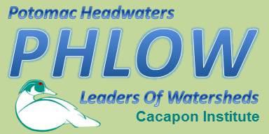

Potomac Headwaters Leaders of Watersheds
Plant-a-Tree Application

Educating future generations of environmental stewards through in classroom education and on the ground conservation practices at schools.

About Plant-a-Tree
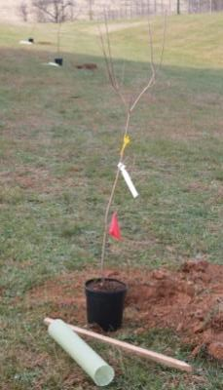

The Plant-a-Tree program requires one education session based around the overall importance of trees within our ecosystem. Students plant trees at the school for their conservation project. Students will plant only native shade or flowering species on their school grounds that increase the aesthetic value at the school but also provide shade, increase wildlife habitat, and capture stormwater runoff pollution.

Lesson:
- Importance of Trees: Students review the overall structures of a tree, and the benefits that trees provide to communities and ecosystems.
Program Includes:
- One, fifty minute, lesson lead by Cacapon Institute’s Watershed Education Specialist
- Work collaboratively with the school to develop a planting plan and species selection
- Mark the location of the trees with spray paint prior to planting
- Provides the trees, stakes, arbor strap, bark protector tubes, mulch, and tools for planting day
- Leads the planting with each class or group of students School Responsibilities:
- Work collaboratively with Cacapon Institute to plan the education and planting day, select tree species, and planting plan
- Contact Miss Utility within the proper time frame for the planting and digging of holes
- Arrange volunteers to dig holes prior to planting day
- Transportation of trees from storage facility to school
- Keep a record of all volunteer hours for final project report

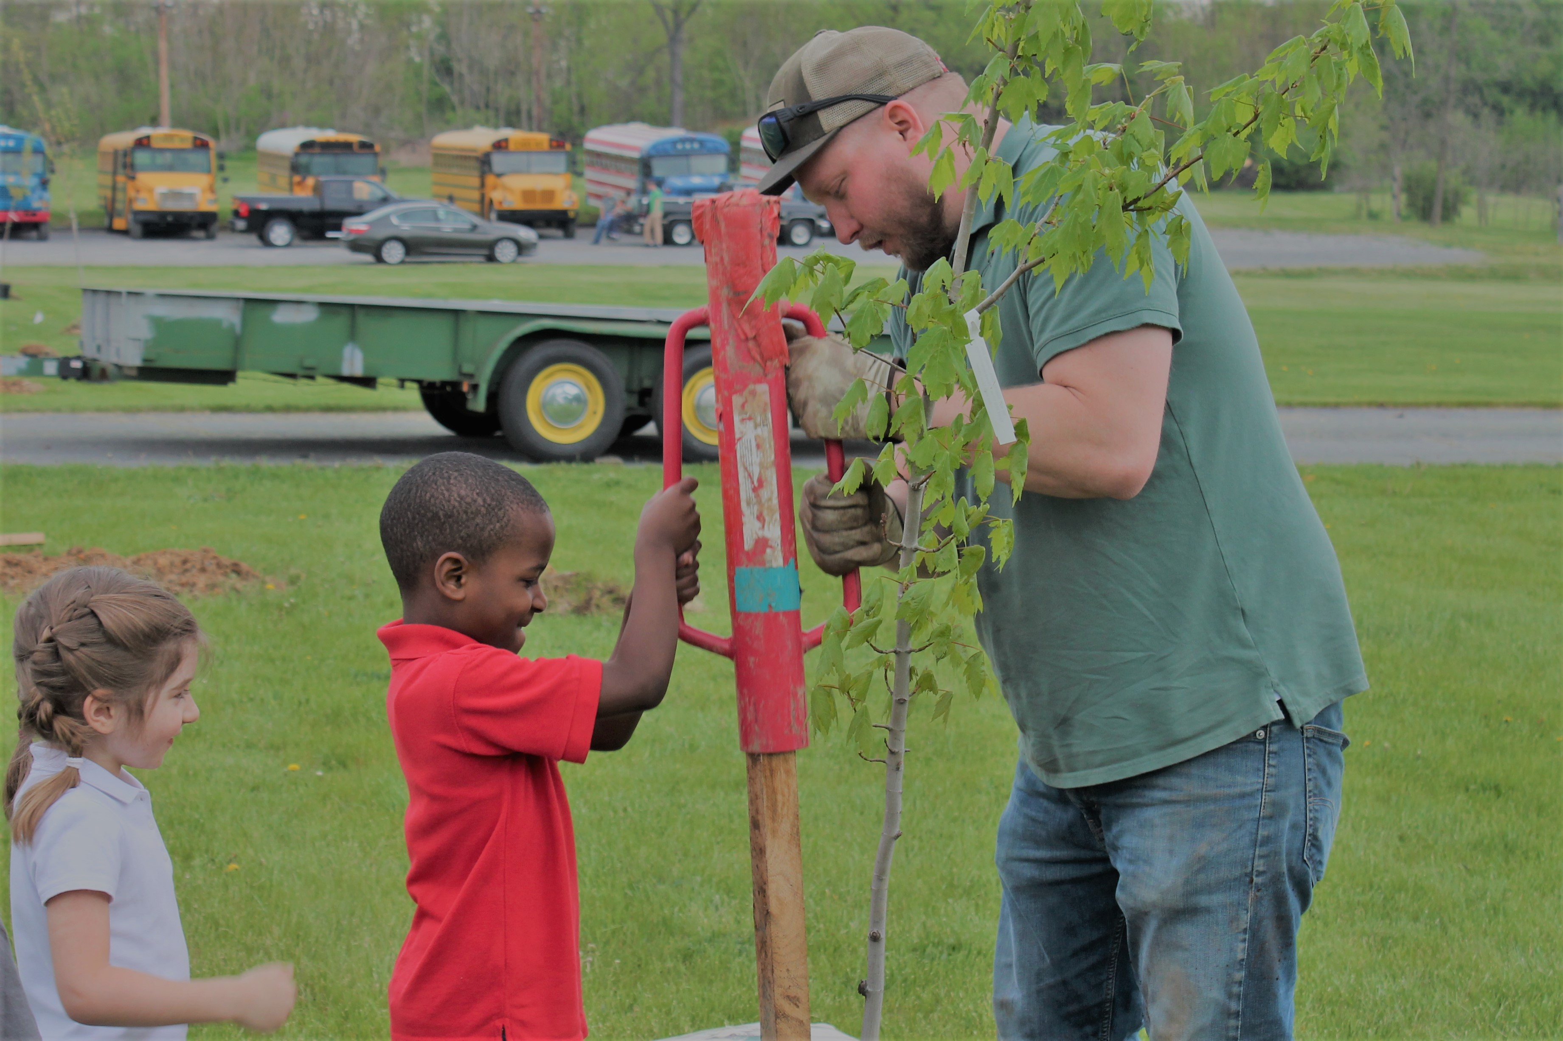
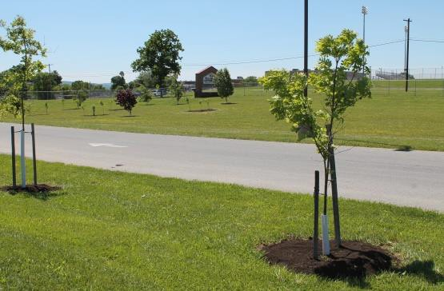

Requests welcome from:
- Public or private schools within the Eastern Panhandle of West Virginia, Shenandoah Valley, or Western Maryland

Application Requirements:
- Program takes place within a school system and on school property
- Located within the Eastern Panhandle of WV, Shenandoah Valley, Western Maryland
- Commitment to coordination of class lesson instructed by Cacapon Institute
  - Must take place prior to tree planting
- Assistance in the planning and execution of the tree planting
- Ongoing maintenance of trees

To Apply:
- Email Application – Watershed Education Specialist, Cacapon Institute
pphlow@cacapo ninstitute.org
- Mail- PHLOW Cacapon Institute, 10 Rock Ford Rd, Great Cacapon, WV 25422

Note: Please apply for only one program a season. We encourage whole grade levels to participate.

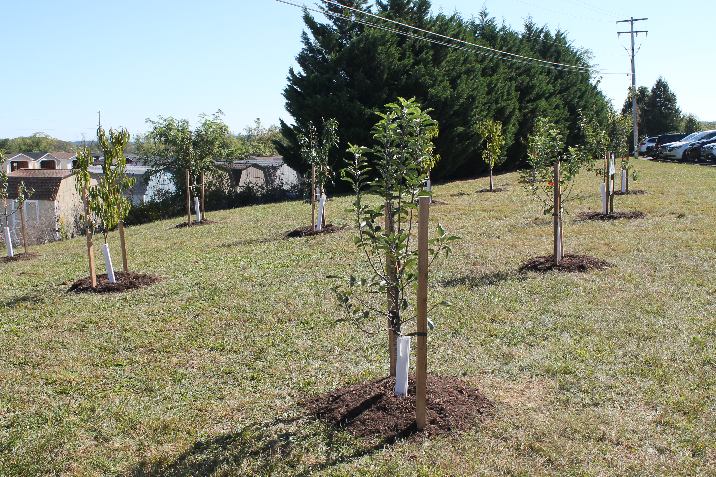

Plant-a-Tre e PHLOW Proposal

Cover Sheet

School Name:
School Address: |  |  | County:
Grade Level: | Number of Classes: |  | Total Number of Students:
Name of Project Leader: |  |  | Job Title:
Phone Number: |  | Email:

Suggested Dates: Please provide one education date and a planting date for the project.

Importance of Trees Education Lesson | Planting Day

Class Schedule: Please provide a tentative agenda for the education day

Teacher Name | Class Time

Project Abstract (Briefly describe your project in less than 5 sentences):

If project is accepted, we grant Cacapon Institute permission to contact us annually and use planting and site pictures for future publications. (Check Box)

- Description of Need. Please be sure to address the following:
  - What do teachers hope their students will gain from the education session?
  - How will a conservation project be an asset to the school in regards to reducing stormwater runoff pollution and future educational uses?
  - Has your school installed a conservation project before?

Objectives and Goals for this Request
What are the short-term and long-term objectives, goals, and benefits of this program? In addition to addressing the specific information above, discuss how the program will foster community involvement, future education plans, and proper care of the trees.

Sunlight Exposure
Site C hec kl ist
Check All That Apply

Full Sun Part Sun Shade

Moisture Level
Pooling Water Downspout Flooding Runoff Catchment Area

Topography
Rocky Conditions Storm Drain Highly Compacted Soil

Soil Texture Soil Compaction
Clay Loam Sand │ None Moderate Severe

Other Soil Features
Active Soil Erosion Recent Construction Other Soil Disturbance

Potential Conflicts
Overhead Wires Structures Pavement Heavy Pedestrian Traffic Wetland Present Mowing Conflict Storm Drain Underground Utilities

External Downspouts

Planting Site
Explain any potential locations at the school for the trees. You can include a photo or google images to help demonstrate location(s) in your application. If applicable, select tree species:

Maintenance Agreement Form

In consideration of Cacapon Institute’s PHLOW Programs providing technical support, native trees, and materials we agree to:
- Grant Cacapon Institute volunteers, agents, contractors permission to inspect and/or provide maintenance on conservation practices installed at:

Project Address City State Zip
- Provide proper maintenance for trees planted through the program for five (5) years by:
  - Checking soil moisture weekly during the months of June- September and providing 5-10 gallons of water each week, as needed, depending on soil conditions and precipitation.
  - We agree to maintain a three inch layer of brown hardwood mulch around the trees.
  - Avoid the use of fertilizers, herbicides, and other chemicals without performing soil tests of consulting a “Licensed Pesticide Applicator”. Results of such tests are to be reported to Cacapon Institute before application.
- Hold Cacapon Institute and its volunteers, agents, contractors harmless from any liability arising from the planting or care of any trees planted under this agreement.
- Maintain Rain Barrel (if installed) by:
  - Removing any leaf matter that may accumulate in the fall
  - Draining and leaving the valve open during the winter months with temperatures below freezing
Failure to fulfill these maintenance requirements will make your group ineligible to apply for programs in the future.
Name: Date:

Mailing Address:

City: State: Zip:

Email: Phone:

